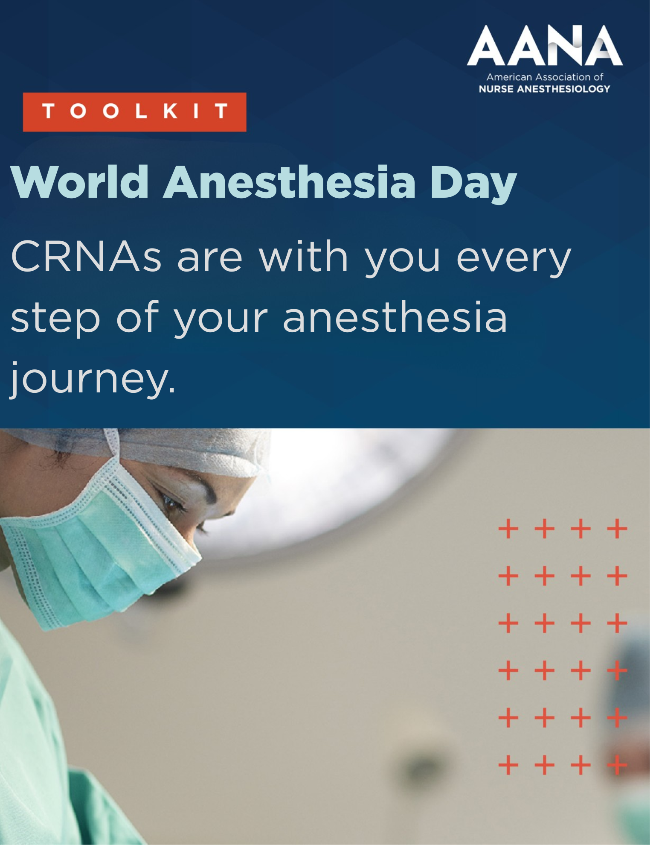

How to Use This Toolkit
This toolkit includes AANA-approved messaging and sample social content to help you celebrate World Anesthesia Day and recognize the vital role CRNAs play in providing safe, high-quality care throughout every patient’s anesthesia journey.
You do not need to use everything in this toolkit. Think of it as a menu of ideas and resources to help you share your story, celebrate the profession, and engage your audience in a way that feels authentic to you.
A few important things to know:
- All messaging in this document has been approved by AANA and is designed to support World Anesthesia Day celebrations.
- We encourage you to personalize the social copy with your own experiences, perspectives, and passion for the CRNA profession.
- World Anesthesia Day is an opportunity to highlight the impact CRNAs make every day and celebrate the profession’s commitment to safe, patient-centered care.
- Please consider tagging AANA social channels!
  - Instagram: @aanaphotos
  - Facebook: @AANA/ American Association of Nurse Anesthesiology
  - LinkedIn: @American Association of Nurse Anesthesiology (AANA)
  - X: @aanacrna

Profile Frame

How to Use Profile Frame:
- Choose a tool such as Canva or Adobe.
- Upload your profile image.
- Upload the profile frame.
- Drag the profile frame to center around your profile image.
- Save the profile image with the frame and update your profile picture on your social platforms.

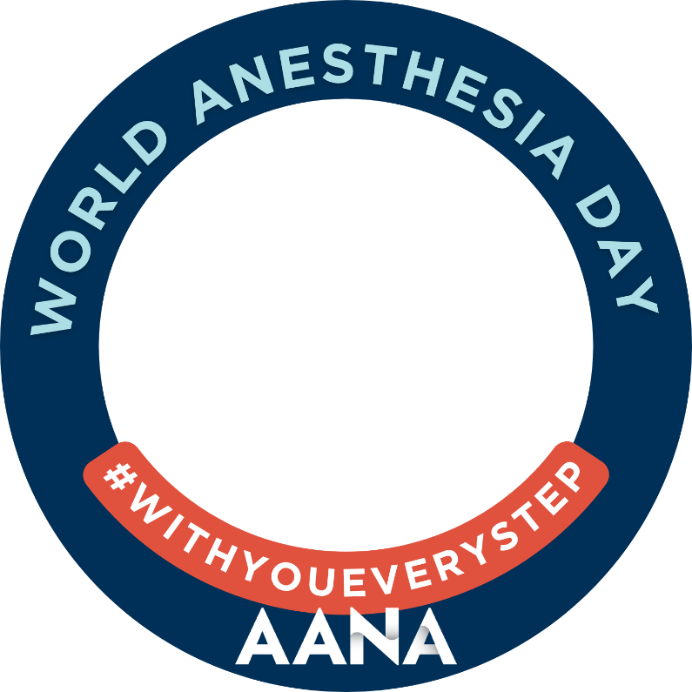

Graphic & Suggested Social Media Copy #1
Suggested Social Copy:
On #WorldAnesthesiaDay, I’m proud to join AANA to celebrate the impact Certified Registered Nurse Anesthetists (CRNAs) make every day in operating rooms, labor and delivery units, surgical centers, military settings, and rural communities across the country.
As a CRNA, it’s a privilege to care for patients during some of the most important – and vulnerable – moments of their lives by providing safe, high-quality anesthesia care. CRNAs are with you every step of the way.
#WorldAnesthesiaDay #WithYouEveryStep #AANA

Graphic:
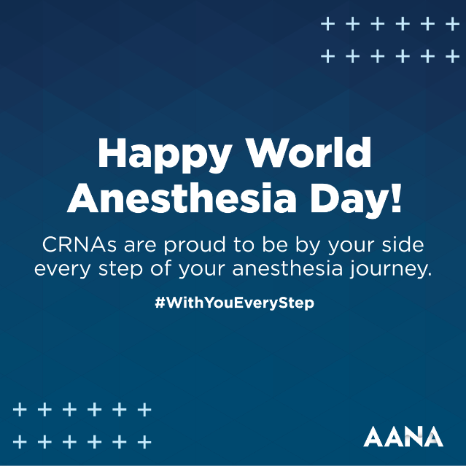

Graphic & Suggested Social Media Copy #2
Suggested Social Copy:
Happy World Anesthesia Day!
I’m proud to join AANA in celebrating the vital role anesthesia professionals play in healthcare. As a Certified Registered Nurse Anesthetist (CRNA), it’s a privilege to care for patients, advocate for their safety, and provide support through every step of their anesthesia journey.
#WorldAnesthesiaDay #WithYouEveryStep #AANA

Graphic:
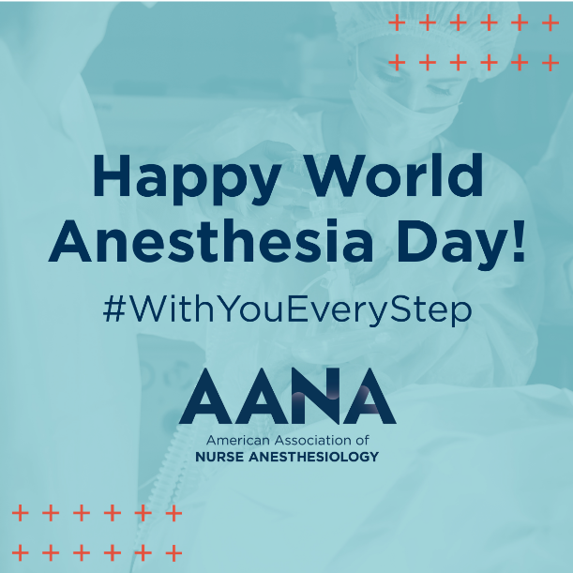

Graphic & Suggested Social Media Copy #3
Suggested Social Copy:
This World Anesthesia Day, I’m proud to celebrate the impact Certified Registered Nurse Anesthetists (CRNAs) make every day. Across hospitals, surgical centers, military facilities, and rural communities, we help ensure patients have access to safe, high-quality anesthesia care when and where they need it most. It’s a privilege to be part of a profession committed to improving access, advancing patient safety, and being there every step of the way.
#WorldAnesthesiaDay #WithYouEveryStep #AANA

Graphic:
